Seminar Registration Taft/

Wednesday, September 19, 2007 2:00 to 4:30 p.m.
Reception following seminar

Mandalay Banquet Center
2700 E. River Rd. Dayton, Ohio 45439 (937) 294-6600

Your Organization

Mailing Address Phone Number

Attendees:

Name: e-mail:

Name: e-mail:

Name: e-mail:

The above individuals will automatically be added to our mailing list. If you prefer not to be added to the list,
please check here and include your initials: 

Four ways to register:

- Complete this form and fax it to Pam Fisher at (937) 228-2816.
- E-mail us with the above information at fisher@taftlaw.com.
- Call Pam Fisher or Lori Fullenkamp at (937) 228-2838.
- Complete this form and mail it to Pam Fisher at Taft Stettinius & Hollister LLP, 110 N. Main St., Suite 900, Dayton, Ohio 45402.

There is no charge for this seminar. Please Register by Friday, September 14, 2007.

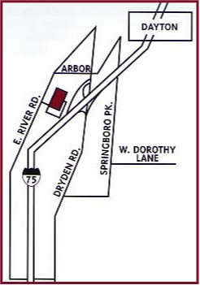

Directions to the Mandalay:

I-75 North or South to Dryden Road Exit 50-A.
Turn Left (from either exit ramp) to Arbor Blvd.
(Holiday Inn on corner). Follow until it ends at
East River Road. Turn left. Entrance is on left
(Metallurgical Services in on right directly across
the street).

